Amazon_Rekognition
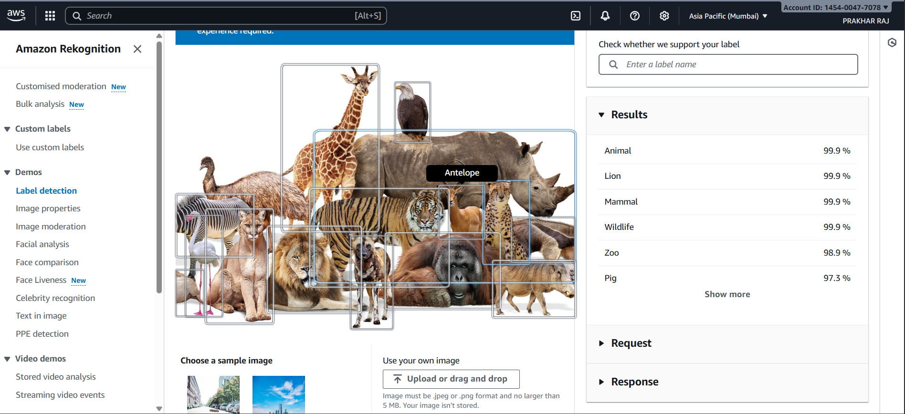
AWS Rekognition – Label Detection
The screenshot shows the Label Detection demo of Amazon Rekognition, where an image containing multiple wild animals is analyzed to identify objects and categories.
1. Image Analysis
Amazon Rekognition automatically detects several animals in the uploaded sample image.
Each animal is outlined with a bounding box and labeled (e.g., lion, giraffe, rhino, tiger, antelope, etc.).
2. Detected Labels (with Confidence Scores)
Rekognition generates a list of labels with very high confidence percentages:
Label | Confidence
Animal | 99.9%
Lion | 99.9%
Mammal | 99.9%
Wildlife | 99.9%
Zoo | 98.9%
Pig | 97.3%
These labels represent what Rekognition identifies in the image along with how confident it is about each detection.
3. Additional Options
On the left sidebar, Rekognition shows multiple demo features available, such as:
- Image properties
- Image moderation
- Facial analysis
- Face comparison
- Custom labels
- PPE detection
4. Image Input Options
The user can:
- Select a sample image, or
- Upload or drag-and-drop their own image (JPEG or PNG, up to 5 MB).

